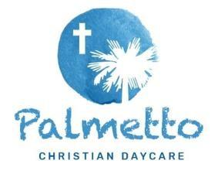
Palmetto Learning Academy Philosophy & Curriculum

Philosophy: At Palmetto Learning Academy we proudly incorporate a child centered and play-based philosophy into our classrooms and teaching styles. Purposeful play builds the foundation for children to grow and understand their learning environment as well as the world around them. At Palmetto Learning Academy, in addition to learning developmentally appropriate academics, our children learn independence through play. They also learn from their peers, constantly encouraged, and are challenged by their teachers in a safe, loving, educational environment. By providing a child-centered & play-based learning philosophy, we are giving our students the opportunity to use their innate capacity to strive toward growth and maturity. Our passionate staff will utilize their skills in consciously guiding and redirecting our students toward desired behaviors, goals, and achievements. Our child centered and play-based philosophy is also based on CEO & Founder, Early Childhood Educator, and Author Lisa Murphy’s seven play based-principles that focus on the ability for children to discuss, move, play, observe, read, create, and sing. When it comes to the Christian principles that we tie into our program, our goal is to lay a gentle foundation by having our students focus on one character trait and bible story per month. We have specially selected the traits and stories which our teachers creatively implement into the academic lesson plans each month.
Curriculum: As for our academic curriculum at PLA, we start implementing more of our full academic curriculum once students transition into our 2K room. Once students reach our 2K, we begin our Handwriting Without Tears program. Once students are in our 3K & 4k program, they begin our DIG Curriculum which they will use until they graduate from our 4k program. Our DIG Curriculum gives Pre-K learners strong skills that develop the whole child by inspiring learning across all domains. It grows early learners into confident kindergarten-ready students. The components of DIG are divided into the following sections:
- The Letter People – DIG Pre-K uses the power of The Letter People to make learning safe and fun while modeling how to solve problems, resolve conflict, and build meaningful relationships.
- Daily Integrated Math – The DIG Pre-K curriculum offers daily math—and not just once, but three times a day—in whole group, small groups, and integrated learning centers.
- Dedicated Time to Assess – DIG Pre-K’s progress monitoring tools guide teachers to better lesson planning, consistent review and reteaching, and a greater awareness of each child’s progress.
- Daily Robust Vocabulary – Our DIG curriculum gives children multiple opportunities to build oral language through daily “Wow Words,” hands-on practice, and home connections.
- Daily Active Literacy – DIG Pre-K literacy routines get children talking, singing, and moving their bodies as they explore emergent reading with the help of Dr. Jean Feldman and The Letter People.
- Rich and Intuitive Resources – The DIG Pre-K curriculum offers flexible and accessible teacher resources that are chock full of research-based best practices, expert tips, and point-of-use guidance that help all teachers learn and grow.
The most important aspect of our academic curriculum is that of our Letter People. This is focused on our kid-friendly, kid-durable puppets that are good friends, language buddies, learning partners…and just plain fun! Based on over 30 years of classroom research and testing, these special friends get children talking, moving, interacting, experimenting, drawing, counting, and ultimately, reading and writing. Children of all ages form an immediate connection with the cute and quirky Letter People Puppets. They want to learn all about their new friends, and when they do, they are also learning letter names, letter sounds, and a wide variety of oral language skills.
Read more about our DIG curriculum here: https://www.frogstreet.com/wp-content/uploads/2022/01/EXH2430_DIG_PreKBrochure_FINAL1.pdf
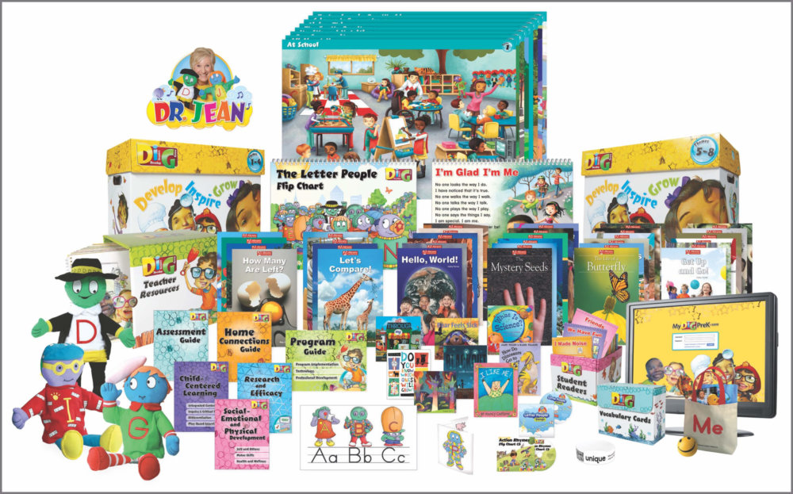

PALMETTO MONTHLY LESSON PLAN THEMES

January:
Theme All about me, exploring my emotions and self care
Trait Perseveration
Bible Story Noah’s Ark

February:
Theme Showing Love and Kindness to Others
Trait Kindness
Bible Story The Good Samaritan

March:
Theme Going to the Circus and Dr. Seuss
Trait Creativity
Bible Story Exodus

April:
Theme Bugs and Insects exploring the dirt and nature
Trait Determination
Bible Story Leviticus 11:21-22 Will pass out a print out for this bible story.

May:
Theme Wildlife and Habitats
Trait Courage
Bible Story Daniel and the Lions Den

June:
Theme Earth, Space,Dinosaurs and Fossils
Trait Faith
Bible Story Creation

July:
Theme Ocean Under the Sea and summer fun
Trait Leadership
Bible Story Moses Parting the Red Sea

August:
Theme Back to School and Transportation
Trait Obedience
Bible Story Jonah and the Whale

September:
Theme Let’s Go Camping
Trait Adventours
Bible Story Adam and Eve

October:
Theme Pumpkins and Halloween
Trait Bravery
Bible Story The Story of David

November:
Theme Farming and Thanksgiving
Trait Thankful
Bible Story Parable of the Sower (Matthew 13)

December:
Theme Winter fun and Christmas
Trait Peace
Bible Story Birth Of Jesus

